Sl No |  | Name |  | Designation |  | Age & Date of Birth | Registration No. | Qualification | Date of Joining | Previous Teaching Experience | Address | Email ID | Phone No. | Photo
DEPARTMENT OF MOULIKASIDHANTA
1 |  | Dr. Deepthi Krishna |  | Associate Professor |  | 39 Yrs  02.01.85 | TCMC  9950 | BAMS MD Ayurveda Samhitha&Sidhanta | 03.10.23 | 10 Yrs | Krishnanjali Konnamankara, Pathanamthitta | deepthik7474@gmail.com | 9400617727 | 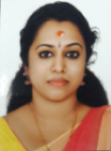
2 |  | Dr. Rismiya S |  | Asst. Prof. |  | 36 Years  21.07.86 | TCMC  12442 | BAMS MD Ayurveda Samhitha&Sidhanta | 31.03.21 | Nil | Menethu Puthanpurayil, Varavila PO  Clappana  690528 | drrismiyas@gmail.com | 9447867255 | 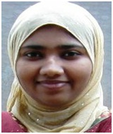
3 |  | Dr. Anishma A S |  | Asst. Prof |  | 36 Years  20.05.86 | TCMC  10444 | BAMS MD Ayurveda Samhitha&Sidhanta | 02.02.22 | Nil | Krishna Kripa  Near Post Office  Balussery | asanishma34@gmail.com | 9497287178 | 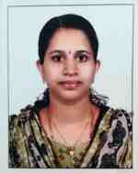
4 |  | Mrs.Prajisha |  | Sanskrit Lect. |  | 37 Years  22.05.84 |  | MA Sanskrit, BEd. | 01.04.17 | 8 Years | Thalakkottu House, Pannikkotoor, Kerala | prajisuraj@gmail.com | 9645149669 | 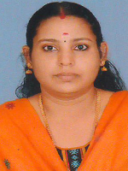
DEPARTMENT OF RACHANASAREERA
5 | Dr.Archana Radhakrishnan |  |  |  | Asso Prof | 39Years  30.08.82 | TCMC  9933 | BAMS MD Rachanasareera | 01.01.15 | Nil | Neeliparambath House, Chemencheri PO, Kozhikode | drarchanasijesh82@gmail.com | 9567626095 | 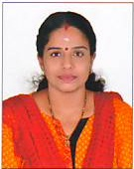
6 | Dr. Manju P S |  |  |  | Asst. Prof | 32 Years  04.01.90 | TCMC  15412 | BAMS MD Rachanasareera | 09.06.22 | 2 Yrs | Sarovaram  Mezhathur  Thrithala | manjusarovarammez@gmail.com | 8848326932 | 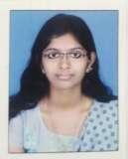
DEPARTMENT OF KRIYASAREERA
7 |  | Dr. Bhavya B S |  |  | Asso. Prof | 36 Yrs  25.11.87 | TCMC  13555 | BAMS MD Ayurveda Samhitha&Sidhanta | 25.10.23 | 8 Yrs | padma nivas, kuttamath, cheruvathur, Kasargod | drbhavyabams@gmail.com | 8547485416 | 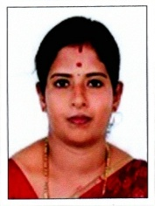
8 |  | Dr. Basil P Jacob |  |  | Asst. Prof. | 32 Yrs  09.02.90 | TCMC  19529 | BAMS MD Kriyasareera | 04.06.21 | Nil | Peediakkal House, Koodathai PO, Thamarassery Via | drbasilpjacob@gmail.com | 8921319275 | 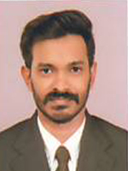
DEPARTMENT OF DRAVYAGUNA
9 |  | Dr. P M Dinesh Kumar |  |  | Prof. | 50 Years  05.03.72 | TCMC  7633 | BAMS MD Dravyaguna | 27-07-09 | Nil | Pallikkamannil House, Avala PO, Meppayur, Kozhikode | pmdkayurveda@gmail.com | 9497074345 | 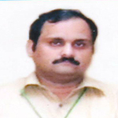
10 |  | Dr. Sreelakshmi S |  |  | Asst. Prof. | 31 Years  30.11.91 | TCMC  15516 | BAMS MD Dravyaguna | 04.0519 | Nil | Sirakripa  Arinalloor South PO, Kollam | sl301191@gmail.com | 9446673212 | 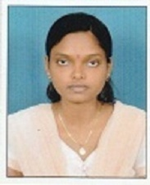
DEPARTMENT OF RASASASTRA
11 |  | Dr. T N Harikrishnan |  |  | Prof. | 45 Years  09.04.77 | TCMC,  7421 | BAMS MD Rasasastra | 01-05-08 | Nil | UshaNivas, Kalpetta, Wayanad | haritn2000@gmail.com | 9946165249 | 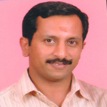
12 |  | Dr. Siji K T |  |  | Asst. Prof. | 38 Years  27.09.84 | TCMC  10506 | BAMS MD Rasasastra and Bhaishajyakalpana | 31.05.22 | Nil | Koloroth House, Quilandy, Calicut | drsijikt@gmail.com | 8301857331 | 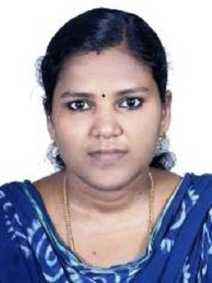
DEPARTMENT OF ROGANIDANA
13 |  | Dr. Nidhin.V |  |  | Asso. Prof. | 37Years  4//9/1985 | TCMC: 11823 | BAMS MD in Roganidanan | 20.09.2021 | 6 Yrs | Valsalyam, 33/6382 B,Karunabhavan road,Kozhikode- | drnidhinvalsan1985@gmail.com | 9847461114 | 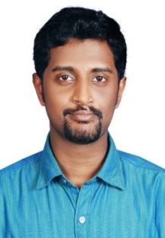
14 |  | Dr. Binju T V |  |  | Asst. Prof. | 34 Yrs  04.07.87 | TCMC  13445 | BAMS  MD Roganidana | 10.04.23 | Nil | Kayyadavazhiyil House, PO North Beypore Calicut | binjuthilak@gmail.com | 9495721696 | 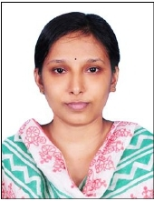
DEPARTMENT OF SWASTHAVRITHA
15 |  | Dr.Sijna V P |  |  | Asst. Prof. | 35 Years  02.05.86 | TCMC  11586 | BAMS MD in Swasthavritha | 25.11.19 | Nil | Flat No. 92, Hilite Eminence, PushpaJuction, Kallai Road, Kozhikode | sijnaraj@gmail.com | 9496136149 | 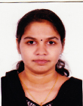
DEPATRMENT OF AGADATHANTRA
16 |  | Dr. Subhasree G H |  |  | Professor/ Principal. | 41 Years  31.05.80 | 8003  TCMC | BAMS MD Dravyaguna | 01.03.2012 | 3 Years | Akkipoyil House  Nanminda PO  Calicut | sree.gh@gmail.com | 7034122951 | 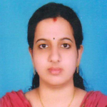
17 |  | Dr.Anjana Mohan |  |  | Asst. Prof | 33Years  31.12.88 | 13018  TCMC | BAMS MD Agadathantra | 06.0519 | Nil | NellipuramVeedu, Palath PO, Kakkodi | dranjanamohan@gmail.com | 9526062416 | 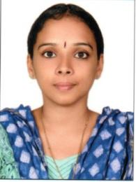
DEPARTMENT OF PRASUTI TANTRA
18 |  | Dr.Aswathy Sara Varghese |  |  | Asso. Prof. | 34 Years  08.07.88 | TCMC  13114 | BAMS MS Prasutitantra | 04.01.18 | Nil | Kolabhagam House, Pathanamthitta | aswathisara88@gmail.com | 9961719796 | 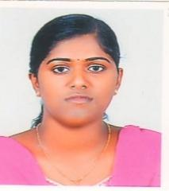
19 |  | Dr. Apila Nath |  |  | Asst. Prof | 29 years  3.02.92 | TCMC  17446 | BAMS MS Prasutitantra | 31.03.21 | nil | Sreekammangate (H)  Balussery (po)  Kozhikode | mkapilanath@gmail.com | 8217042231 | 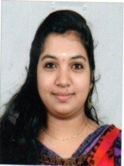
DEPARTMENT OF KOUMARABRITHYA
20 | Dr. Aiswarya Padmanabhan |  |  |  | Asso Prof. | 35 Yrs  07.10.88 | TCMC  12991 | BAMS MD Kayachikitsa | 28.10.23 | 5 Yrs | AISWARYA-H, LIG-542, PANAMAPALLY NAGAR  Ernakulam | draiswaryayurveda@gmail.com | 8156878813 | 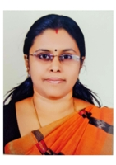
21 | Dr. Divya R P |  |  |  | Asst. Prof. | 33 Years  01.06.89 | TCMC  12751 | BAMS MD Koumarabrithya | 17.06.22 | Nil | Kuttyattillam  Chellannur  Calicut | dr.divya.rp@gmail.com | 9447757966 | 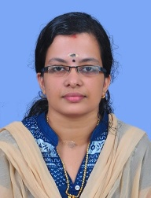
DEPARTMENT OF KAYACHIKITSA
22 |  |  | Dr.Sarun Mohan |  | Prof. | 38 Years  12.05.83 | TCMC  8968 | BAMS MD Kayachikitsa | 03.03.21 | 10 Years | Kandankerry ,Ithithanam P.O,  Changanachery,Kottayam | drsaranmohan@gmail.com | 9846160449 | 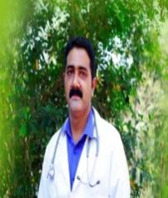
23 |  |  | Dr.Vineetha N |  | Asso. Prof. | 37 Years  09.12.84 | TCMC  10550 | BAMS MD Kayachikitsa | 16.03.15 | Nil | Bright, Kannancherry, Kallai PO, Calicut | drvineetha sarin@gmail.com | 9747106829 | 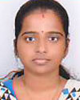
24 |  |  | Dr.Mrudula J |  | Asst. Prof | 32 Years  22.05.87 | TCMC  11004 | BAMS  MD Kayachikitsa | 01.05.19 | Nil | Kumarabhavan, Chengada, Varanod, Cherthala | mrudu007@gmail.com | 8129529794 | 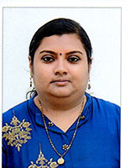
25 |  |  | Dr.Aparna T |  | Assi Prof | 32 Years  10.05.91 | TCMC  14955 | BAMS MD Kayachikitsa | 03.05.19 | 2 Months | Thokkot House, Cherandathur PO, Thiruvallur,  Kozhikode | dr. aparnathokkot@gmail.com | 9497890675 | 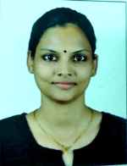
DEPARTMENT OF SALYATANTRA
26 | Dr.Najeeb T K |  |  |  | Asso. Prof. | 44 Years  10.04.76 | TCMC  7831 | BAMS MS Salyatantra | 18.02.21 | 6 Years | Kozhipurath,Kodathoor,Malapuram | drnajeebtk@gmail.com | 9947873825 | 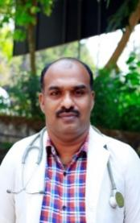
27 | Dr. Fathima T |  |  |  | Asst. Prof | 34 Yrs  11.03.89 | TCMC  15255 | BAMS MS Salyatantra | 18.12.23 | 2 Yrs | Thelappurath, Edarikode PO, Perumanna, Malappuram | fathima1189@gmail.com | 9447508753 | 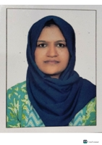
DEPARTMENT OF SALAKYATANTRA
28 | Dr. Sharon P Vals |  |  |  | Asso. Prof. | 34 Years  04.01.88 | TCMC  13553 | BAMS MS Salakyatantra | 02.07.22 | 5 Yrs | Kathalekkattil House, Manassery PO, Mukkam, Kozhikode | sharonfinbe@ymail.com | 9400675898 | 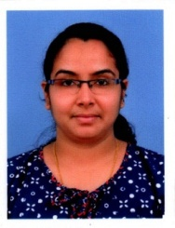
29 | Dr. Meenu P R |  |  |  | Asst. Prof. | 29 Years  26.03.93 | TCMC  17706 | BAMS MS Salakyatantra | 18.12.21 | Nil | Rakendu  Vattolli Bazar  Balussery  Calicut | meenupraphul92@gmail.com | 8547392951 | 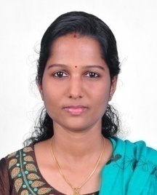
DEPARTMENT OF PANCHAKARMA
30 | Dr.Arathy V |  |  |  | Asso. Prof. | 32 Years  12.07.89 | TCMC  12796 | BAMS MD Kayachikitsa | 16.11.16 | Nil | Thiruvonam House, Kizhakkumpatt, Mayanad, Kozhikode | arathiayu@gmail.com | 9895870192 | 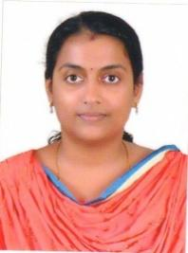
31 | Dr. Priyanka P S |  |  |  | Asst. Prof. | 30 Years  05.03.92 | TCMC  18376 | BAMS MD Panchakarma | 03.02.22 | Nil | Cresent Zennia Appartments, Flat No. 3 B, Thodayad Bypass, Calicut | priyasukumaran123@gmail.com | 9048669931 | 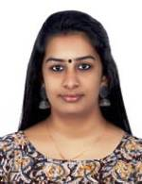
32 | Dr Nayana T M |  |  |  | Yoga Teacher | 25 Year  17.07.95 | 1108 | BNYS | 10.10.19 | Nil | Kattumadathil House,Kinalur PO, Balussery | nayanamanoj555@gmail.com | 8495884342 | 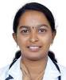
33 | Mr Durgesh Kumar |  |  |  | Biostatician | 33 Years  01.03.87 | NA | MSc | 01.01.17 | Nil | PakkamHouse,Pakkam PO, Panayal , Kasargod | durgeshkumark@gmail.com | 9048025214 | 